**ACTIVITY – 3**

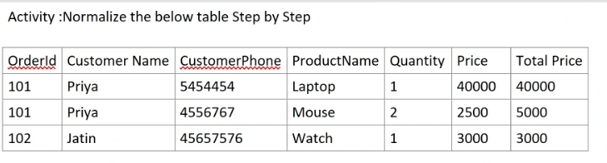

**1NF:**

Here, we have Atomic values only (no multiple values).

So, 1NF is satisfied which is the same as question.

| **OrderId** | **Customer Name** | **CustomerPhone** | **ProductName** | **Quantity** | **Price** | **Total Price** |
| --- | --- | --- | --- | --- | --- | --- |
| 101 | Priya | 5454454 | Laptop | 1 | 40000 | 40000 |
| 101 | Priya | 4556767 | Mouse | 2 | 2500 | 5000 |
| 102 | Jatin | 45657576 | Watch | 1 | 3000 | 3000 |

**2NF:**

Must be in 1NF.

No partial dependency.

Here, we have Primary Key (Composite key) = (OrderId, ProductName)

But, Customer Name and CustomerPhone depends **only on OrderId**, not on the whole composite key. So, it’s **partially dependent**.

Hence, in **Order Table** we have removed product info and kept customer info. Then in **OrderDetails Table** we have kept only product-related details.

**Order Table**

| **OrderId** | **Customer Name** | **CustomerPhone** |
| --- | --- | --- |
| 101 | Priya | 5454454 |
| 101 | Priya | 4556767 |
| 102 | Jatin | 45657576 |

**Order Details Table**

| **OrderId** | **ProductName** | **Quantity** | **Price** | **Total Price** |
| --- | --- | --- | --- | --- |
| 101 | Laptop | 1 | 40000 | 40000 |
| 101 | Mouse | 2 | 2500 | 5000 |
| 102 | Watch | 1 | 3000 | 3000 |

**3NF:**

Must be in 2NF.

No transitive dependency.

After doing 2NF we have 2 tables where there is no issue with the Order Table but in Order Details Table we have a derived column.

(i.e) Total Price = Quantity × Price

No Non-key attribute should depend on another non-key attribute.

Total Price is **transitively dependent** on Quantity and Price.

So, we have excluded Total Price from Order Details Table.

**Order Table**

| **OrderId** | **Customer Name** | **CustomerPhone** |
| --- | --- | --- |
| 101 | Priya | 5454454 |
| 101 | Priya | 4556767 |
| 102 | Jatin | 45657576 |

**Order Details Table**

| **OrderId** | **ProductName** | **Quantity** | **Price** |
| --- | --- | --- | --- |
| 101 | Laptop | 1 | 40000 |
| 101 | Mouse | 2 | 2500 |
| 102 | Watch | 1 | 3000 |

**BCNF:**

Must be in 3NF.

Every determinant is a Candidate key.

For **every** functional dependency **X → Y**, **X must be a candidate key**.

**Functional Dependencies:**

* OrderId → Customer Name, CustomerPhone
* (OrderId, ProductName) → Quantity, Price

BCNF is already satisfied.

**Order Table**

| **OrderId** | **Customer Name** | **CustomerPhone** |
| --- | --- | --- |
| 101 | Priya | 5454454 |
| 101 | Priya | 4556767 |
| 102 | Jatin | 45657576 |

**Order Details Table**

| **OrderId** | **ProductName** | **Quantity** | **Price** |
| --- | --- | --- | --- |
| 101 | Laptop | 1 | 40000 |
| 101 | Mouse | 2 | 2500 |
| 102 | Watch | 1 | 3000 |